IB Comp Sci IA:
Solution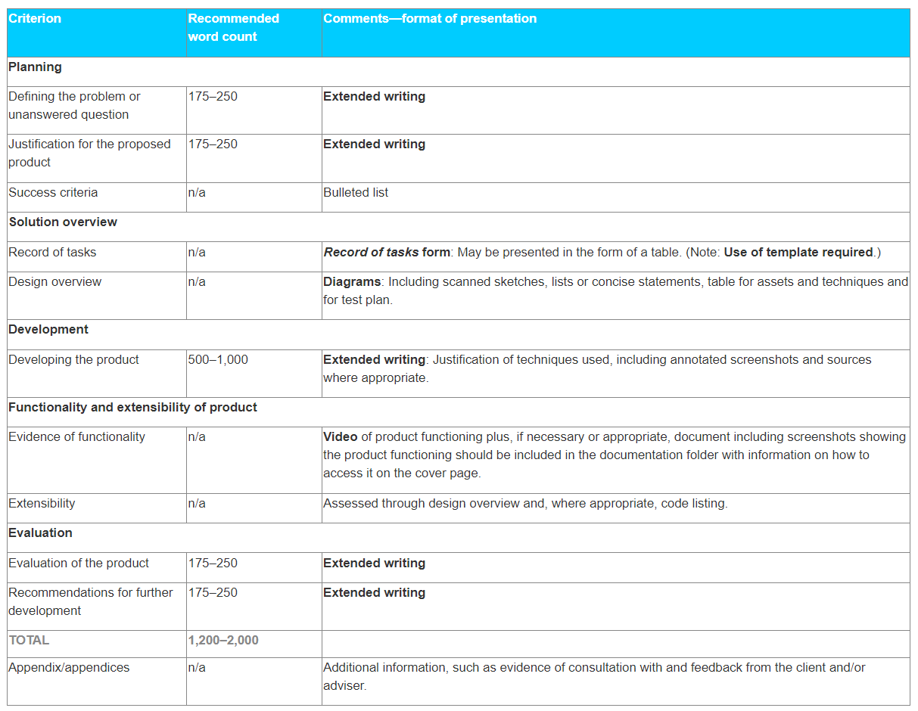

Focus on Criterion A

SOLUTION (and max. 2,000-word supporting documentation) focused on providing either an original product or additional functionality to an existing product for a client.

SOLUTION = Cover page (using template) + the product + the <2,000-word documentation

*Develop a solution for a specified client to a specified problem or unanswered question.

Three roles to identify in the solution:
- The “developer” and “student” are synonymous.
- The “client” is the person for whom the product is being developed. (Can be the student themself)
- The “adviser” is a third party the student must identify to assist him or her in the development of the product. (Client can act as adviser as well)

ORGANIZATION OF DOCUMENTATION
CRITERION | DOCUMENTATION SECTION | GUIDANCE AND WRITING ADVICE
A: Planning  Successful Criterion A examples:  Lamar student’s successful example  6/6 Criterion A from IB example 8  5/6 Criterion A from IB Example 6 | Defining the Problem or Unanswered Question  ~175-250 words  → The specific client’s specific problem or unanswered question  ~and~  → The client’s user-facing specifications for the solution | - Opening 1-2 paragraphs  Briefly establish the specified client’s situation  - Relevant context leads into specific “situation” client finds themselves in  - One short paragraph  Narrow in on the issue and define the specified problem or unanswered question. Examples:  - “[Client] approached me and suggested that I develop [a solution] that could mitigate this issue”  - Or: [a solution] that could reliably answer this question  - “In [the Client’s] perspective, a [solution] with provisions for [x, y, z], will respond to or mitigate the issue [in this way _______]”  - Final paragraph of section  Provide the client’s requested specifications– include as many user-facing numerical, system/interface, and feature specifics as possible. Examples:  - “[The Client] has requested the development of a(n) _[solution]_____ that would provide [users] _____”  - “The [solution] would possess/feature/include ____[X, Y, and Z]___”  - “[Users] should be able to ___[interact in X, Y, Z ways with the solution]___.”  - Address: user access, login, viewing, modifying, interacting, saving; back-end data collection, management, etc., if client requested  - “[Client] also suggested that [A feature/functionality] be set up or incorporated, but stated that it was not required.”  - Refer to documentation in appendix:  “(see Appendix [1, …]).”  **Remember to emphasize the client’s meaningful role in describing the problem and their desired solution. Do not let it sound like you’re merely describing a pre-determined solution.**
A: Planning | Section:  Rationale for Development  ~175-250 words | - Explicit rationale for the solution  ~One brief paragraph: outline functional product  - Clarify if expanding existing product/system or creating new; how will new integrate with existing system or device  - Product type (Android/iPhone app, web app, website, widget, etc.)  - Product’s basic affordances for user experience (APIs, interface, personalization, modification, ease of use, size/scope of capabilities, connectivity, etc.)  ~One brief paragraph: design choices  - Define elements/components and Design choices  - Show where your choices reflect client’s specifications  - Show where your design choices aim at intuitive, efficient, robust, or otherwise advantageous functional product  - Explicit rationale for software being used  ~One+ brief paragraph(s): technical Comp Sci choices  - Justify coding languages  - Justify programming structure  - Identify and justify database and querying choices  - Identify one or more opportunities for extensibility  Justify these choices with respect to client’s specifications and what you know technically about computer science principles and tools.
A: Planning | Section:  Criteria for Success  Bulleted list  (word count n/a) | Include 8 to 10 specific, measurable Criteria for Success  Ex.  - “Users can ____” (include 5+ criteria specifically referring to user interface capabilities)  - “Program will ___”  - “Design is _____”  - “Display will ____”  - “Administrators can ___”  - “[X] data will be recorded in a ___, accessible via ____”  The Criteria for Success are extremely important for a strong project.  Write your criteria for success items so that you can ANNOTATE YOUR CODE WITH SPECIFIC REFERENCE TO THE CRITERION ITEM!!  Example:  “//Item 1: Users can log in with a username and password; Function: Registering an account login//” before corresponding coding
B: Solution Overview | Record of Task | Make sure your Record of Task documents reflect the need to address a real problem with a real solution, including Criteria for Success.  Make sure your Overview and Record of Task documents refer to a proper implementation stage during which the client uses the final product for its intended purpose and provides feedback.  Use of template required.
B: Solution Overview | Design Overview | Include one or more iterations of the overall design or overall product map.  Organize using subheadings for detailed design components/features.  For each section’s  Diagrams  Flowcharts  Storyboards  Data Structures  Provide a brief written explanation that shows ample evidence of your algorithmic thinking. Also be sure to:  - Indicate in writing where design components correspond to specific Criteria for Success  - Indicate in writing where you’ve designed for extensibility.  - Emphasize in writing where design components and choices respond to Client’s feedback as documented in the Appendix  → In your Overview, highly recommend referring to an initial client (and/or adviser?) feedback session on a proposed Design Overview, and how you responded to or implemented their feedback into the final design
C: Development | Development  ~500-1000 words | For each section of code, provide a brief written explanation that shows ample evidence of your algorithmic thinking. Also be sure to:  - Indicate in writing where code components correspond to specific Criteria for Success  - Explain in writing how your coding choices evidence your algorithmic thinking and understanding of computer science tools and techniques  - //Annotate in code// and explain in writing where you’ve consciously programmed extensibility into your product.  - Emphasize in writing the computer science tools and techniques that respond to Client’s feedback as documented in the Appendix
D: Functionality and Extensibility of product | Evidence of functionality | Video
D: Functionality and Extensibility of product | Extensibility | “Assessed through design overview and, where appropriate, code listing.”  (see criteria breakdown image below)
E: Evaluation | Evaluation of the product  ~175-250 words
E: Evaluation | Recommendations for further development  ~175-250 words
Appendices |  | Evidence of consultation with and feedback from client;  Evidence of consultation with and feedback from advisor;  Other information

Flow chart of stages in the development of the IA Solution
